THIẾT BỊ CHO PHÒNG HỌC CÔNG NGHỆ 4.0
1. SMARTBOARD SBID-7286P 86" 4K UHD Interactive LED Display with IQ
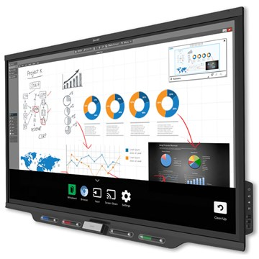

Price: 11.000 USD; Hãng: Smarttech
2. Hệ thống thực tế ảo HTC Vive Pro
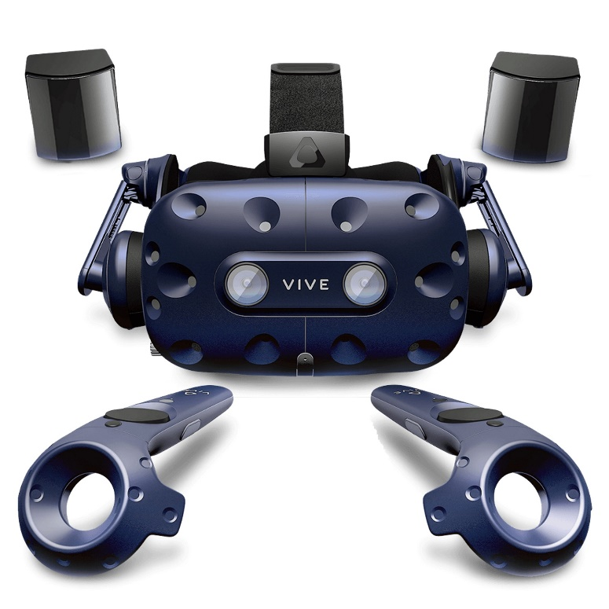
Price: 5000 USD; Hãng: HTC
3. Cánh tay robot UR3e
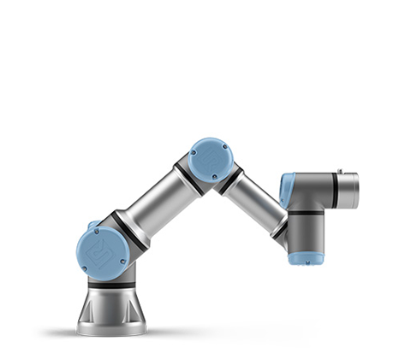

Price: 40000USD
Hãng: Universal Robots
4. Máy quét 3D Metrascan 3D
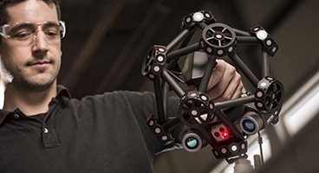
Price: 50000USD
Hãng Creaform
The main evolutions of the Creaform MetraSCAN compared to its predecessor are:
1.5X more accurate
12X faster with 7 laser crosses
25% lighter
Scan any type of material, even black, multicolored and shiny surfaces
Greater volume of 16.6 m3 (586 ft3)
Sturdy design for shop-floor hardware reliability
Multi-function buttons for easier interaction with the software
Recommended size of parts is 0,2 – 6 m.
5. PC
- Processor: Intel® Core™ i5-4590 or AMD FX™ 8350
- Graphics: NVIDIA® GeForce® GTX 1070/Quadro P5000
- Memory: 32GB
- SSD: 1TB

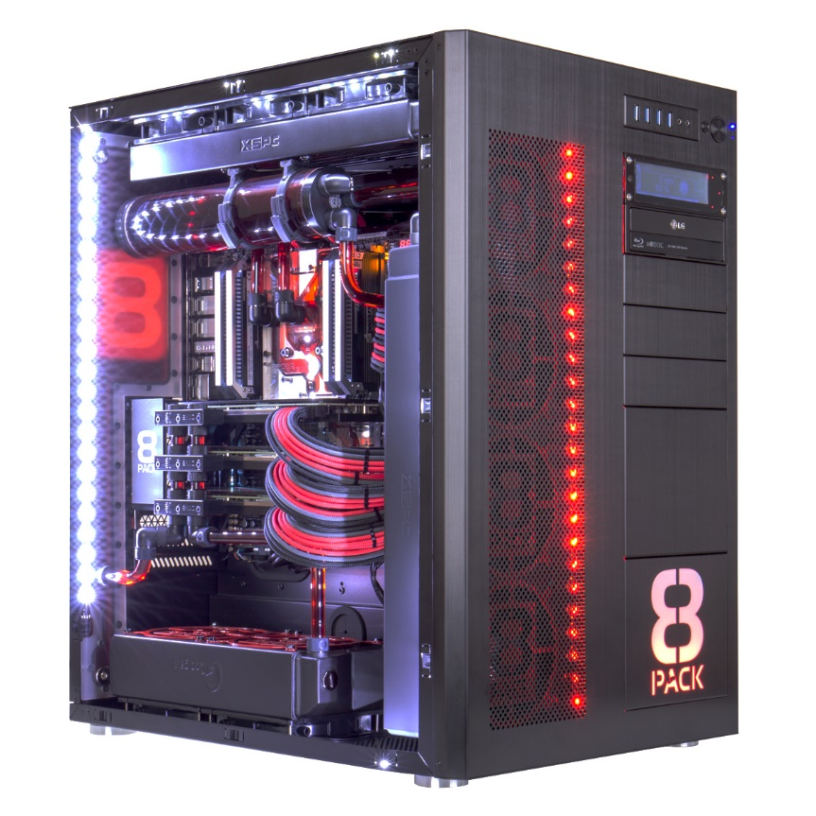
6. Phần mềm thiết kế CAD chính hãng:
- Solidworks/Creo Parametrics
7. Máy in 3D mini:
FabPro 1000
Hãng 3D Systems
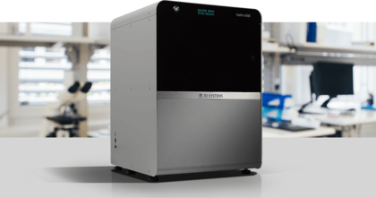
- Uses Digital Light Printing (DLP) Stereolithography technology
- Max build envelope capacity (W x D x H): 125 x 70 x 120 mm (4.92 x 2.76 x 4.72 in)
- 3D Sprint™ robust software solution for additive manufacturing
- High-quality materials excel across a wide range of applications
8. Máy CNC mini
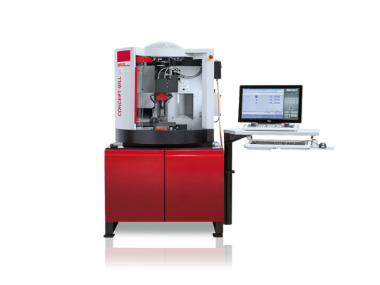
CONCEPT MILL 55
Compact CNC desktop Milling machine
High-resolution axis motors
Automatic 8 station tool turret
Infinitely adjustable main drive
Engraving Spindle Facility
NC dividing unit as an optional fourth axis
Robotic interface for integration into FFS/CIM systems
Safety technology according to the latest lathes standard
Made in the Heart of Europe

